

SQL Practice – Entity Relationship Diagram

**Deadline: Friday, October 09th 2020, 09:00 AM**

[**GitHub Classroom Repository**](https://classroom.github.com/a/Sy1UI12U)

# Introduction

This practice is meant to challenge your mastery of ERD and how well you can break down a client’s needs into a database design. Your goal in this practice is to create a zoo management system which helps a zoo keep track of animals and exhibits. Being able to create Entity Relationship Diagrams will help you to create well-formed databases in the future.

In our zoo:

Every species has a common name, scientific name, class, habitat, diet (C, H, O) and a Red List Status based on this image:

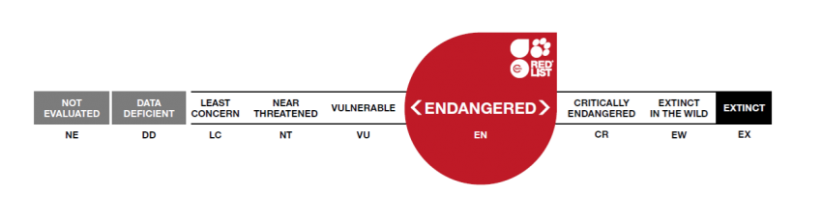

An animal has a staff member who is assigned to look after it. Every animal has one staff member assigned but a staff member can look after many different animals. Staff have names. Feel free to add other fields you think a staff member should have. An animal has a name, gender, weight in lbs, date of birth, date of departure, and departure circumstances. Every animal has a species. A species can have many animals.

The zoo has exhibits. An exhibit has a start and end date as well as a description and name. Every exhibit can have multiple animals and an animal can belong to many exhibits.

**Challenge(s):**

Sometimes animals will enter a breeding program and will produce offspring. The zoo needs a way to track the lineage of animals.

Animals have enclosures they live in. More than one animal may live in an enclosure if the animal is of a species that lives in groups. The zoo would like to know details about the enclosures animals live in and be able to track what animals live in what enclosure.

An animal’s health, just like a human’s health, can change. The zoo would like to know what health an animal is in at any given moment.

# Requirements

* Your ERD should be 3NF.
* Datatypes should be present in your ERD.
* There should be at least once associative entity.
* Use Draw.io to make your ERD

# Hints & Tips

* Identify Entities and Attributes first, then focus on their Relationships.
* Focus on the requirements first, challenges are extra!
* This project has been done by many others in the past! Don’t hesitate to use your google-fu skills if you don’t know how to implement certain features!

# Reminders

Ensure you are tracking your time and that your timesheet is in the appropriate folder for viewing and marking.

Ensure you are committing frequently. It is advised to commit once per successful feature implementation at a minimum.

Ensure you are pushing your repository to the GitHub Classroom repository, and not a personal, private repository.

Ensure your repository has a readme with at a minimum your name, the name of the project, the project’s purpose and a link to your Trello board.

Ensure you are using Trello appropriately to keep track of outstanding features, and that it is linked in the README.md file.

Ensure you are using the #class channel to request clarifications on assignment specifications.

Ensure you are using the #homework-help channel in slack to request for assistance from instructional staff if needed, and that you include (at a minimum) a specific description of the problem and a list of what you have tried.

Feel free to reach out on #peer-support if the #homework-help queue is lengthy. If someone helps you out, [give them a shoutout using our handy-dandy form](https://docs.google.com/forms/d/1dKWKfNMABm8XmsB5iik5djcathQ3CT5g10-0rD7xGz0)!